**Excel Assignment – 12**

**1. What is the total amount of stationary bought from Madhya Pradesh?**

The total amount of stationary bought from Madhya Pradesh is 176971.

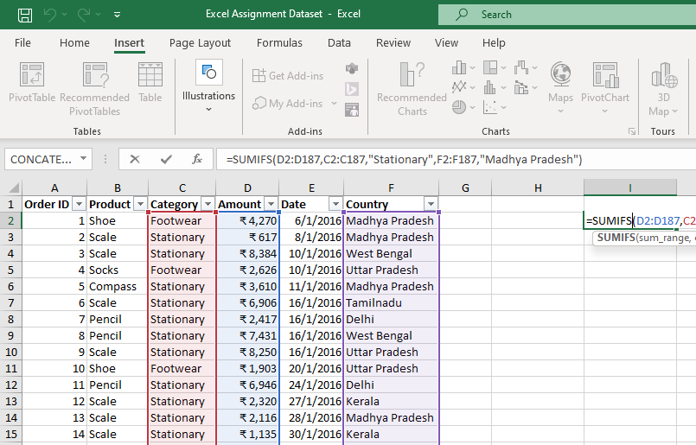

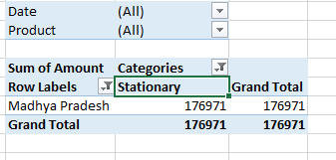

**2. What is the total count of stationary bought from Tamilnadu?**

The total count of stationary bought from Tamilnadu is 13

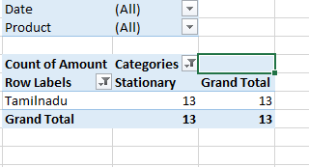

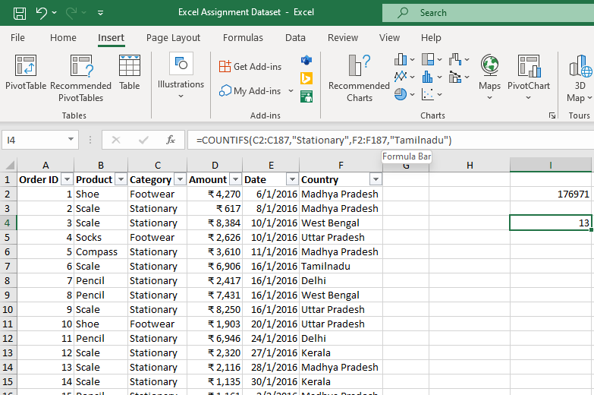

**3. What is the total amount spent on footwear?**

The total amount spent on footwear is 194226

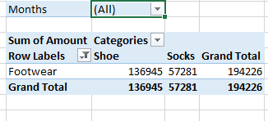

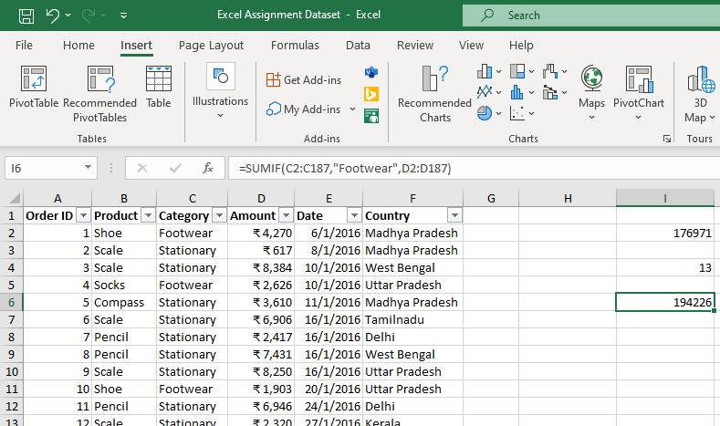

**4. What is the total amount of money spent for stationary in July?**

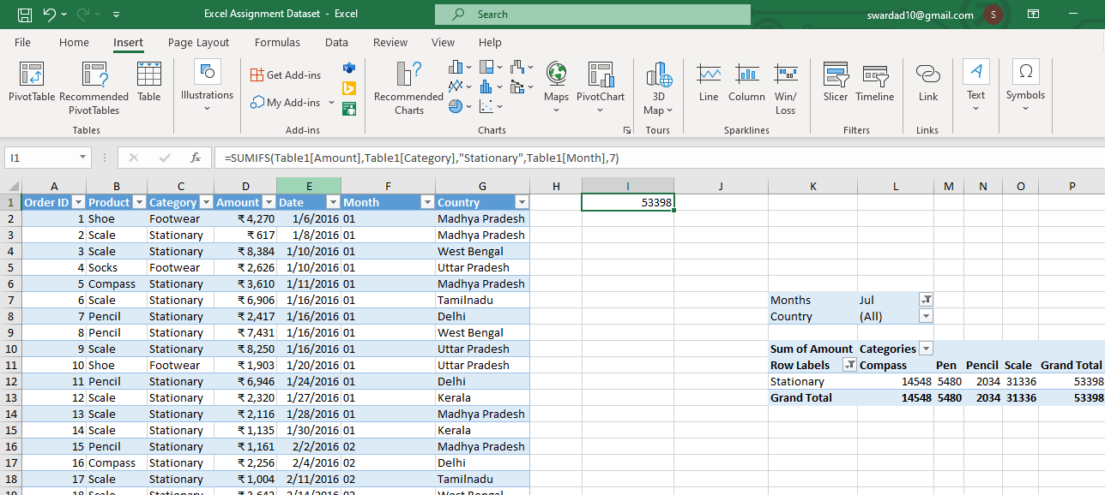

**5. What is the count of footwear that is coming from Delhi?**

